`

Department of Mechanical Engineering

EMCH 368
MECHATRONICS

Lab 01
Introduction to Arduino and Circuits

Last Edited: 01/08/2024 by J. Vaught
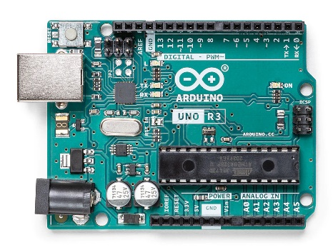
For this lab, we will be using the Arduino UNO board. Major parts to note on this board is the USB port on the top right, the 5V and ground pins located on the middle-left, and the digital input/output pins along the right edge.

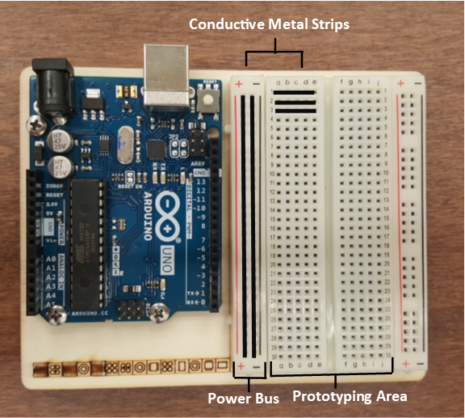
The breadboard is the primary place you will be building circuits. This breadboard is solderless, meaning that the components can easily be placed onto and removed from the breadboard without soldering. On the furthermost left and right sides of the breadboard, there are vertical metallic strips that run the length of the board. These are usually where power (+) and ground (-) are connected.
The 5 holes in each horizontal row are connected with metal strips as well. The gap between the rows of 5 holes breaks the connection between the two sides of the board. Of course, the two sides could simply be wired together if needed.

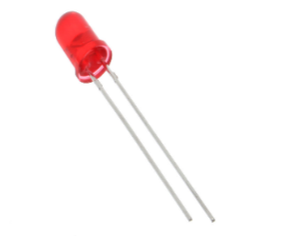
An LED, or light-emitting diode, is a component that converts electrical energy into light energy. LEDs are polarized components, which means they only allow electricity to flow through them in one direction. The longer leg, called the anode, is connected to power while the short leg, called the cathode, is connected to ground. When current flows from the anode and cathode, the LED emits light.

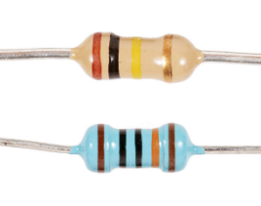
A resistor is a component that resists the flow of electrical energy. Some of this electrical energy gets transformed into heat energy. When a resistor is put in series with an LED, for example, the resistor uses some of the electrical energy and the LED receives less energy as a result. Resistors allow you to manipulate the amount of energy supplied to each component, which is useful since not all components require the same amount. In the case of the LED, it would receive too much current without a resistor and quickly burn out.
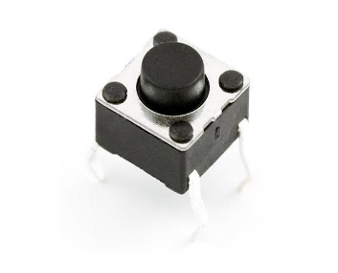
A switch interrupts the flow of electricity, breaking the circuit when open. When a switch is closed, it will complete a circuit. There are many types of switches. The ones in your kit are called momentary switches, or pushbuttons, because they are only closed when pressure is applied.

Assembling your Arduino Board
You are receiving the Arduino Starter Kit. This kit comes with everything you need to learn the fundamentals of circuit design. Take a moment to look through the kit and discover what all is included in your box. The components are stored in smaller boxes and should all be labeled. Be sure to take care of all your components and return them to the proper boxes when you are finished with each lab so that you stay organized.

Before we build our first circuit, let’s assemble a working platform that holds both the Arduino UNO board and a bread board:
- Locate the wooden (or plastic) base.
- Carefully punch out all the wooden parts from the base. Also be careful not to lose any pieces.
- Place the Pieces marked with an “A” (although the pieces themselves are shaped like Es) into the holes in the corners of the wooden base. Put them into the holes from the bottom of the base. This will create the feet for our working platform.
- Secure the Arduino UNO board to the platform using 3 screws and 3 nuts in the 3 circular holes of the wooden platform.
- Do NOT peel the backing from the breadboard. Removing the peeling and attaching to the plastic base plate may cause damage to the Breadboard and cause malfunctioning rows in future labs.

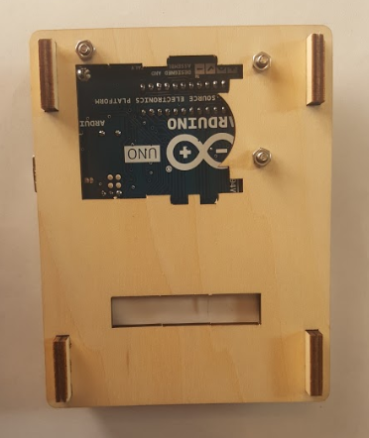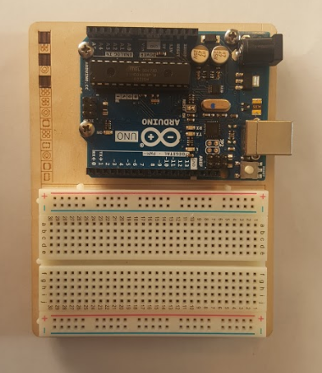
Exercise 1: Building Your First Circuit
You are going to use the Arduino for this exercise, but only as a source of power. When plugged into a USB port or a 9-volt battery, the Arduino will provide 5 volts between its 5V pin and its ground pin that you can use. NOTE: Whenever you are building/deconstructing your circuit, make sure the power supply is UNPLUGGED.

Materials:
- 1 set of long red and black jumper wires
- 1 220-ohm resistor
- 1 LED

Building the Circuit:
- Connect a red wire to the 5V pin on the Arduino, and put the other end in one of the long (+) bus lines in the breadboard.
- Connect a black wire to the ground pin on the Arduino to the adjacent long (-) bus line on the breadboard.
- Use a 220-ohm resistor to connect power from the (+) bus to a row in the prototyping area.
- On the other side of the resistor, connect the anode (long leg) of an LED. Connect the cathode (short leg) of the LED to a hole in a different row. Ground the cathode to the (-) bus.
- Connect the Arduino to power by connecting it to your computer through USB. The light should turn on!

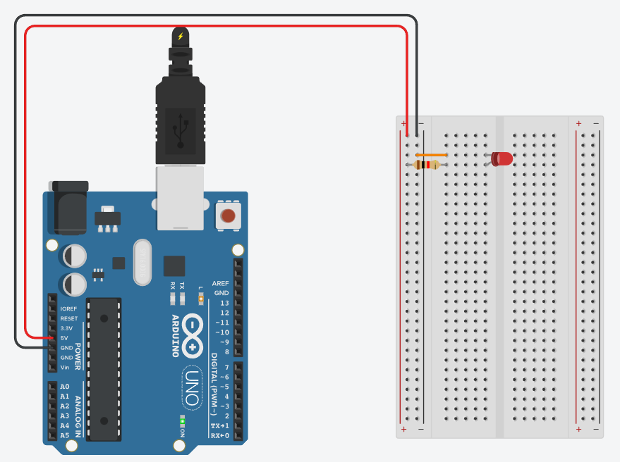
Exercise 1 Circuit

Exercise 2: Making an Interactive Circuit
In this exercise, you will be creating an interactive circuit by adding a switch.

Materials:
- 1 set of long red and black jumper wires
- 1 220-ohm resistor
- 1 red LED
- 1 switch

Building the Circuit:
- Remove the USB power supply before tampering with the circuit.
- Remove the LED and its ground connection in the circuit you made in the previous exercise.
- Add the switch to the row containing the 220-ohm resistor. Place the switch across the center of the breadboard. The bend in the legs of the switch should point towards the center of the board.
- Connect anode (long leg) of an LED to the bottom part of the switch. Ground the cathode (short leg) of the LED.
- Connect the USB power, and observe what happens. What happens when you press the button? What happens when you hold down the button?

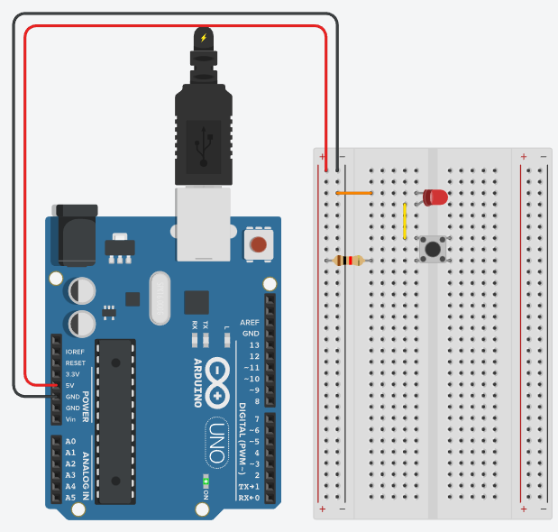
Exercise 2 Circuit
Exercise 3: Series vs. Parallel Circuits
In this exercise, you will create two different circuits that demonstrate the principles of having components connected in series versus being connected in parallel.
Materials:
- 1 set of long red and black jumper wires
- 1 220-ohm resistor
- 1 red LED
- 2 switches

Part A - Building the Circuit:
- Remove the USB power supply before tampering with the circuit.
- Remove the LED and its ground connection in the circuit you made in Exercise 2.
- Add another switch to the circuit and connect them directly.
- Connect the anode (long leg) of an LED to the other side of the new switch and ground the cathode (short leg).
- Connect the USB power supply and observe what happens. What happens when you press either button? What happens when you press both? Is this a series or a parallel circuit? Get the TA to check your work.

Part B - Building the Circuit:
- Remove the USB power supply before tampering with the circuit.
- Remove the wire connecting the two switches
- Connect a wire from one side of the 220-ohm resistor to the top pin of the lower switch
- Connect a wire from the top pin of the lower switch to the anode (long leg) of the LED
- Connect the USB power supply and observe what happens. What happens when you press either button? What happens when you press both? Is this a series or a parallel circuit? Get the TA to check your work.
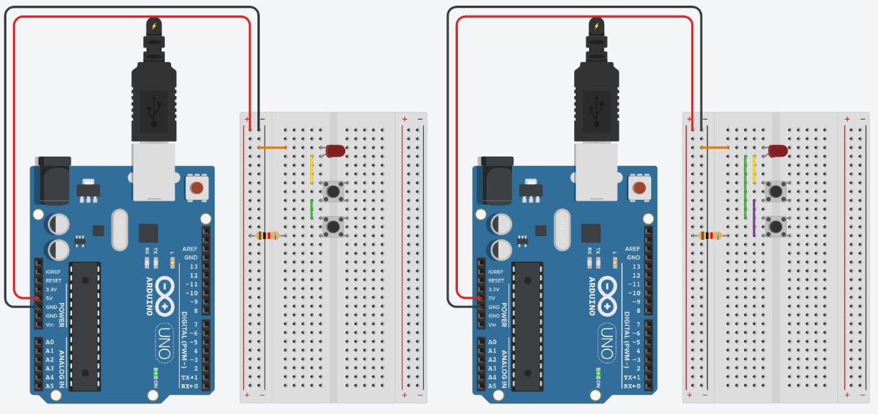
Exercise 3: Part A Circuit Exercise 3: Part B Circuit
Exercise 4: Creating an Interface with Custom Outputs
In this exercise we will explore having both digital inputs and outputs and programming your Arduino circuit to perform custom tasks. Your goal is to create a circuit that meets the following criteria:
- A green light will be on until the user presses a button
- When the button is pressed, the green light will turn off and two red lights will start blinking
- The red lights must clearly blink alternatively from one another
- When the button is released, the red lights stop blinking and the green light turns back on
Materials:
- 1 set of long red and black jumper wires
- 3 220-ohm resistor, 1 10k-ohm resistor
- 2 red LEDs and 1 green LED
- 1 switch
Building the Circuit:
- Reset your breadboard.
- Begin by making sure your red jumper wire is connected to the Arduino 5V pin and the (+) power bus on the breadboard. The black jumper wire should be connected to the Arduino ground pin and the (-) bus on the breadboard.
- Place two red LEDs and one green LED to the breadboard. Attach each cathode (short leg) to ground with a 220-ohm resistor.
- Connect the anode (long leg) of the green LED to digital pin 3 on the right side of the Arduino. Connect the red LEDs to pins 4 and 5 respectively.
- Place a switch across the center divider of the board. Connect one side to power (+) and the other side to digital pin 2. Also, ground the side of the switch connected to the Arduino with a 10k-ohm resistor.
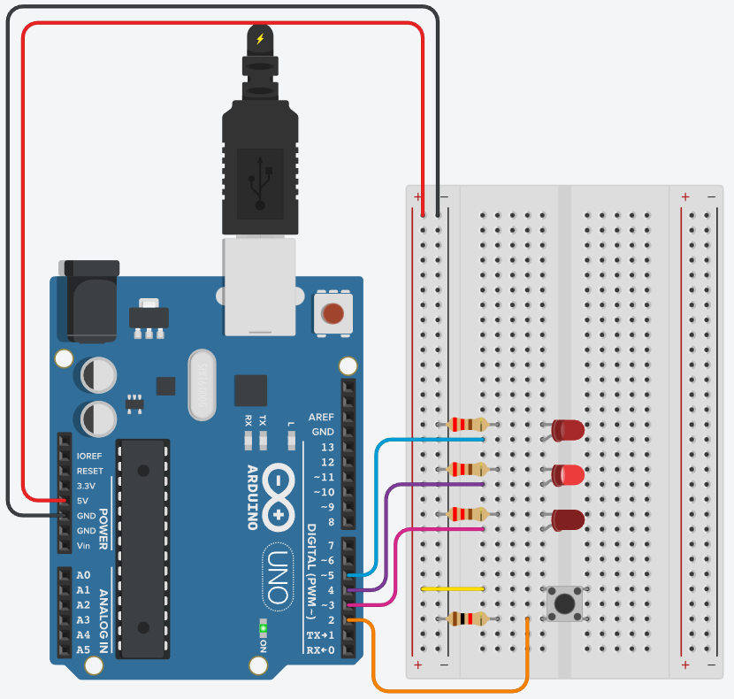
Exercise 4 Circuit
Writing the Code:
From here on out, we will be controlling our circuit by having the Arduino read various inputs and then tailor its outputs to meet the criteria of our circuit’s design. The Arduino software has its own coding language, and these coding files are called “sketches”. The code is broken down step by step below, but for information on specific functions (e.g. what arguments they take) see the appendix at the end of each set of lab instructions.

Begin by opening the Arduino software on your computer. This interface should appear:

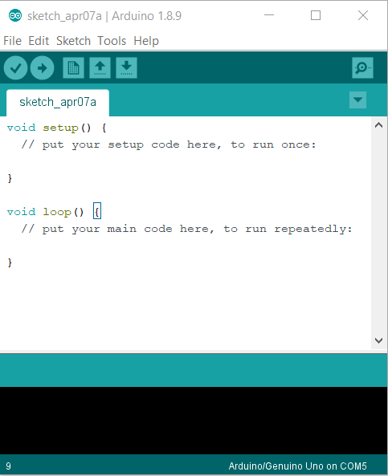

If there is already code written when you open the program, begin a new sketch.

Let’s get coding!
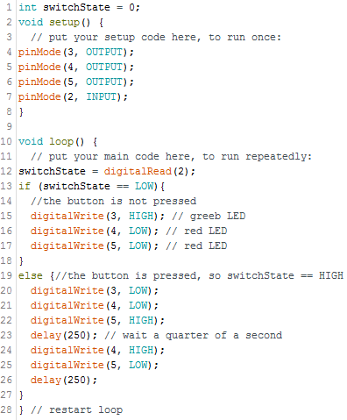

This integer type variable is used to store the state of the circuit’s pushbutton, on or off. If the pushbutton is closed or on, a 1 is stored in this variable. If the pushbutton is open, a 0 is stored in this variable. When we create a variable, we must also give it an initial value. To display the line numbers on the left, go to File > Preferences > “Display Line Numbers”



In this setup portion of the code, the digital pins used of the Arduino are configured as either inputs to be read by the Arduino or as outputs for which the Arduino will apply a voltage under certain conditions.

Note that you can write comments by putting // anywhere in your code. Anything written after the // on that line will be ignored by the Arduino, so they are just for your benefit. Comments are a great way to write out in words what your code is doing. You should make a habit of writing comments for each logical step in your code so that you can keep track of what is going on.



The main part of the code will be placed in the void loop() function. The variable switchState is set to become whatever value is returned from reading digital pin 2. When the switch is closed, digitalRead(2) should return HIGH. When the switch is open, it should return LOW.

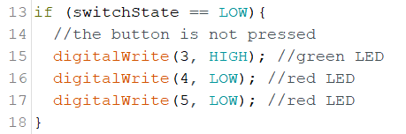

This if statement uses the reading from digital pin 2 to apply/remove voltages to the other pins. If the switch is open, a voltage will be applied to pin 3 and not to pins 4 and 5.


The else() statement declares what happens if the original if() statement’s criteria aren’t met. In this case, what happens when the switch is closed. The green LED is turned off (pin 3 is set to LOW) and one of the red LEDs is turned on (pin 5 is set to HIGH). One of our design criteria stated that the light must alternate from one another. Introduce a delay of 250-milliseconds into the system. After the delay, turn off the illuminated LED and turn on the opposite red LED. Put another 250-millisecond delay into the system.

To check the code for errors, select the Verify button at the top of the display as shown below.

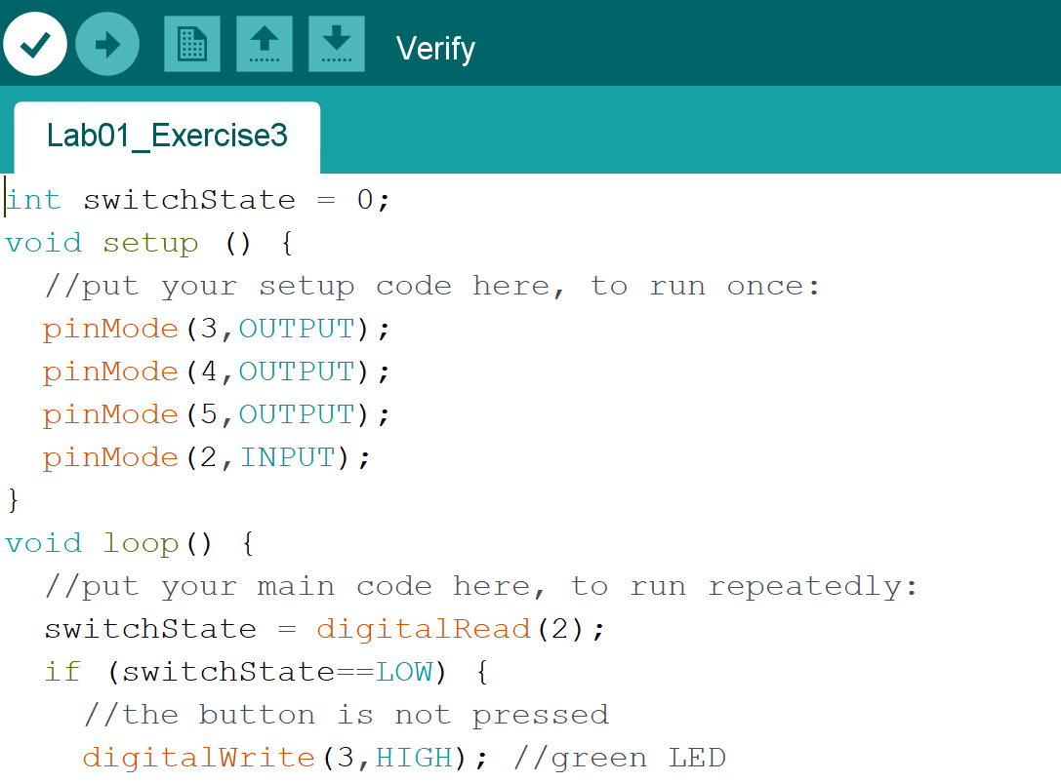

Once the code is free of errors, select the Upload button to submit the code to the circuit.

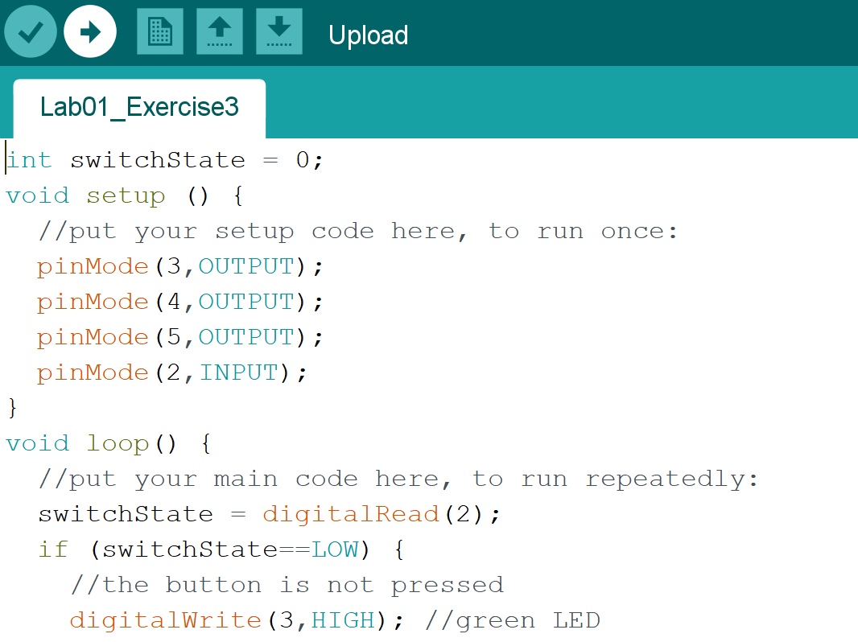
Lab 1 Code Appendix (in order of appearance):

int – Integers are your primary data-type for number storage. On the Arduino Uno an int stores a 16-bit (2-byte) value. This yields a range of -32,768 to 32,767

void setup() - This section of code runs once when the Arduino is powered up. It is typically used to configure the Arduino’s pins as inputs or outputs.

void loop() - This is where the main part of the program runs continuously. Inputs are checked and outputs are updated each time through the loop. Voltage inputs can be from devices such as switches, light sensors, and temperature sensors. Output voltage can be delivered to devices such as motors and lights.

pinMode(pin#, INPUT/OUTPUT) - This function requires an argument so it knows which Arduino pin to configure. Pins can be configured as inputs or outputs.

digitalRead(pin#) - This function also requires an Arduino board pin number as an argument. It reads the HIGH (voltage present) or LOW (no voltage) digital state of the pin. The standard value for HIGH is ~5 volts while the standard value for LOW is ~0 volts. Numerically, a HIGH is considered to be 1 while a LOW is 0. This comes from the binary number system used by computers.

if() and else - These are commonly used decision making statements in programming languages. if() requires arguments to determine whether or not a certain block of code should be executed. IF a given criteria is met, then the code within the brackets will be executed. For example, if the reading from an input is HIGH (meaning that there is a voltage), apply voltage to an output pin to turn on an LED. ELSE is a command that can only be used when preceded by another if() statement. If the original if() statement’s criteria are not met (i.e. the argument is false), then the block of code within the else statement will be executed instead. Using the previous example and adding an else statement, when the input pin reads LOW (instead of HIGH), there will be no voltage across the output pin.

digitalWrite(pin#, HIGH/LOW) - This function is the opposite of digitalRead(). It applies a voltage on the specified pin: HIGH (~5V) or LOW (~0V).

Lab 1 Grading Rubric:
- Circuit fully built but does not fulfill the lab’s requirement. (20 points)
- Exercise #1 works (7.25 points)
- Exercise #2 works (7.25 points)
- Exercise #3 works (7.25 points)
- Exercise #4 works (7.25 points)
Grade distribution template (total 50 points)
- 20 points for a built, but not working circuit
- Exercise grade = (30 points/# of Exercises) * (0, .5, 1) = Zero, Half, Or full Exercise grade

